Sariah’s Kona Picks
Five nights and six days on Hawaiʻi Island
Home base: Aliʻi Drive, Kailua-Kona
Prepared by RoamGenie • August 2026
This is a choose-your-own-adventure list rather than a schedule. Drive times are approximate from the condo and can grow during afternoon traffic. For the best beach conditions, go early, check the surf before entering, and never turn your back on the ocean.
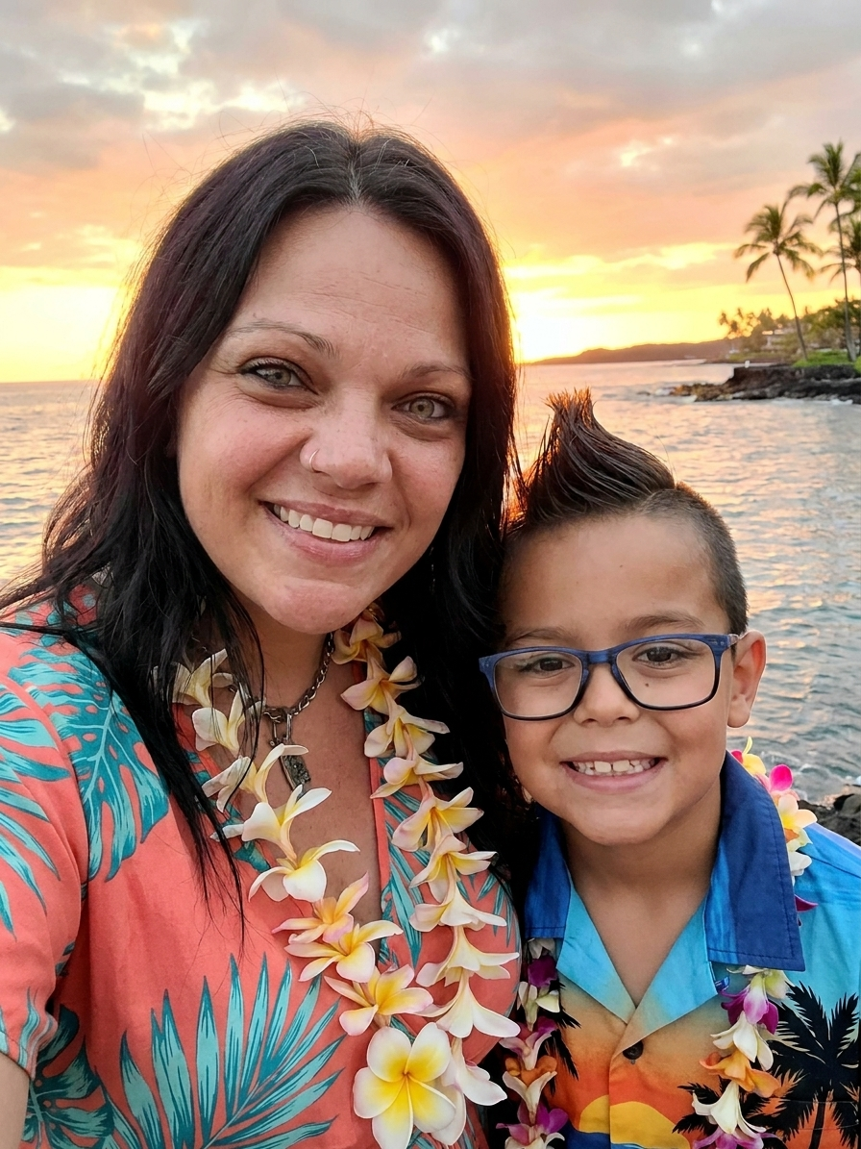
Sariah and Benzen ready for their Kona adventure in aloha wear

Aloha, Sariah and Benzen
Your Kona adventure starts here: beaches, malasadas, manta rays, island drives, and plenty of lanai sunsets. Pick whatever sounds fun each day and enjoy Hawaiʻi at your own pace.

The Condo
Welcome to Nalu Bliss at Kona Nalu, about two miles south of downtown Kailua-Kona. The oceanfront lanai is one of the best places to begin and end the day, especially at sunset. This is also a private residential building, so please observe quiet hours and help protect the home and its neighbors.

Arrival and access
Check-in: 4 p.m. • Check-out: 10 a.m.
The condo is on the second floor. An elevator is available in the center of the building after several steps; the stairs near the designated parking space are usually faster. Door-code and backup-key details are in the private welcome message and are intentionally not posted on this public guide. When leaving, press the top Schlage button, turn the knob to lock, and double-check the door.

Parking
Use the designated condo parking space listed in the private welcome message. Do not occupy it before check-in or after check-out because the property manager and cleaners need it. Limited street parking may be available near the neighboring church; obey all posted signs and do not block residents.

Wi-Fi, television, and Alexa
Wi-Fi credentials are in the private welcome message. The condo also has television and Alexa service. Please do not post or forward access credentials publicly.

Kitchen and supplies
The kitchen includes cookware, knives, wine glasses, a coffee maker, and a coffee grinder. Unopened beverages and condiments left in the refrigerator are available to enjoy. Body wash, shampoo, and conditioner are provided in labeled shower dispensers.

Lanai, pool, and grills
Children must be watched closely on the lanai and at the pool. Keep climbable chairs away from the lanai railing, and remember that the pool has no lifeguard. Use only plastic drinkware on the lanai and around the pool. Unplug the George Foreman grill after every use; a shared charcoal grill is also available near the pool.

Quiet hours and house rules
Please follow all posted quiet hours and pool rules. A house binder is located in the small bar inset opposite the kitchen table and contains the complete condo instructions. Nalu Bliss has neighbors above, below, and on both sides.

If something needs attention
Contact Jeff using the private welcome message or booking thread first. Local property-management contact details are also provided there. Please report any problem promptly so it can be corrected during the stay.

Close to home
Magic Sands is a short walk or very quick drive, although the water can be rough. Downtown Kailua-Kona is only a few minutes away. The lanai is the easiest sunset spot of all, with seasonal whale sightings most common from December through March.

Quick arrival plan
After collecting the rental car at KOA, make one grocery stop before going to the condo. Costco is best for a larger family stock-up. Walmart, Safeway, or KTA work better for smaller quantities. Keep swimsuits, reef-safe mineral sunscreen, water, hats, and towels in the car.

Shopping
Groceries are noticeably more expensive in Hawaiʻi, so buying breakfast food, drinks, snacks, and beach supplies on arrival will save money. Costco, Walmart, Safeway, and KTA are all practical stops between the airport area and the condo.

Costco
From KOA: about 10 minutes • From condo: about 15–20 minutes
Best value for water, drinks, breakfast food, snacks, beach supplies, and family-sized quantities. If Sariah is a Costco member, this is also the best place to fill the rental car with gas. Membership required.

Walmart
From KOA: about 15 minutes • From condo: about 10–15 minutes
Good for inexpensive groceries, toiletries, reef-safe sunscreen, beach towels, coolers, and forgotten necessities.

Safeway
From KOA: about 15 minutes • From condo: about 10–12 minutes
An easy conventional grocery stop. Use a Safeway account or phone number for the sale prices.

KTA Super Stores, Kailua-Kona
From KOA: about 15 minutes • From condo: about 10–12 minutes
A locally owned supermarket that is especially good for poke, prepared food, local fruit, Hawaiian products, and normal-sized grocery quantities.

KTA Keauhou
From condo: about 8–10 minutes south
The easiest place for a quick restock after arrival. It is not on the airport route, but it is close to home.

Beaches
The Kona side is usually calmest in the morning. Beach access is public, but parking at resort beaches can be limited. If surf looks rough or lifeguards are warning swimmers, choose a protected bay or make it a sightseeing day.

Magic Sands / Laʻaloa Beach
From condo: about 3–5 minutes
The closest classic beach. It is fun when the sand is in and conditions are calm, but winter or heavy surf can temporarily carry the sand away. Shore break can be strong, so this is not always the best young-child swimming beach.

Kamakahonu Beach at the Courtyard King Kamehameha Kona Beach Hotel
From condo: about 10–12 minutes
A small, protected sandy bay beside Kona Pier and the hotel. This is the closest dependable kid-friendly beach when Magic Sands is rough or has lost its sand. Public parking and hotel parking policies change; check signs carefully. A nearby coffee purchase may include limited parking validation, but confirm the current terms before leaving the car.

Kahaluʻu Beach Park
From condo: about 7–10 minutes south
The easiest family snorkeling choice. The bay is shallow and protected, with reef fish and frequent turtle sightings. Go early for calmer water and easier parking. Do not touch turtles or stand on coral.

ʻAnaehoʻomalu Bay / A-Bay
From condo: about 35–45 minutes north
A long, family-friendly beach at Waikoloa Beach Resort. Public beachgoers can use unclaimed beach chairs on the sand, but not reserved resort equipment. Lava Lava Beach Club is beside the bay for lunch or daily happy hour, currently 2–4 p.m. Expect a wait near sunset.

Kua Bay / Maniniʻōwali Beach
From condo: about 25–30 minutes north
Bright white sand and turquoise water. There is no advance reservation requirement for an ordinary beach visit. Go early because parking fills, shade is scarce, and the shore break can become powerful.

Kaunaʻoa / Mauna Kea Beach
From condo: about 45–55 minutes north
The first choice for a north-coast beach day. Ask the Mauna Kea Resort guard for a public beach-parking pass. Spaces are limited, so arrive early. If passes are gone, continue to Hāpuna.

Hāpuna Beach State Recreation Area
From condo: about 45–55 minutes north
The reliable backup to Mauna Kea: a broad white-sand beach with lifeguards, restrooms, and showers. Nonresidents currently pay $10 per vehicle plus $5 per person over age three. No ordinary day-use reservation is required.

Restaurants
Kona restaurants add up quickly, so the best strategy is breakfast at the condo, picnic lunches on some beach days, and a few memorable meals out. $**meansbudget−friendly,**$$**moderate,and**$$$ a sunset or vacation splurge.

Breakfast

808 Grindz Café — $
From condo: about 10–12 minutes
Local-style breakfast with pancakes, eggs, fried rice, and generous portions. One of the better values in town. It is generally open for breakfast and lunch, but waits are common.

Big Island Grill — $–$$
From condo: about 10 minutes
A casual local favorite for loco moco, pancakes, omelets, and plate lunches. Good portions for the price. Currently closed Sunday and Monday, so verify before going.

Papa Kona — $$
From condo: about 8–10 minutes
Oceanfront breakfast and brunch in Waterfront Row. Go for the view and split larger dishes if staying on budget. It also works well as a downtown shopping stop.

Hawaiian Style Cafe, Waimea — $
From condo: about 55–65 minutes
Huge local breakfasts and famous pancakes. Best combined with Waimea, Honokaʻa, Waipiʻo Lookout, or a Hāmākua Coast drive. Arrive early and consider sharing because portions are enormous.

Lunch

Da Poke Shack — $–$$
From condo: walkable, about 1–2 minutes
The easiest excellent meal of the trip, in Kona Bali Kai next to the condo. Fresh poke bowls and Hawaiian plates. Go near opening because popular choices sell out.

Kona Crust Pizza — $
From condo: about 12–15 minutes
Casual New York-style pizza and an easy budget meal for kids. Slices make this less expensive than a full sit-down lunch.

Ultimate Burger — $–$$
From condo: about 15 minutes
Big Island grass-fed burgers near Target. Casual, quick, and family-friendly.

Rainbow Cafe — $
From condo: about 18–22 minutes
No-frills Chinese food near Costco with large portions and reasonable prices. Useful before or after a Costco run rather than as a special destination meal.

Broke Da Mouth Grindz — $–$$
From condo: about 15–20 minutes
Big-flavored local comfort food and plate lunches. Portions are generous, so sharing can keep the bill down.

Umekes Fish Market Bar & Grill — $$
From condo: about 12–15 minutes
Popular for poke, fresh fish, tacos, and Hawaiian dishes. More expensive than Da Poke Shack, but good for a casual sit-down meal.

Lava Lava Beach Club — $$–$$$
From condo: about 40–45 minutes
Beachfront lunch or happy hour beside A-Bay. The setting is the reason to go. Daily happy hour is currently 2–4 p.m.; waits are common, so put your name down before you are hungry.

Dinner, sunset, and pupus

On the Rocks at Huggo’s — $$–$$$
From condo: about 7–10 minutes
Go for sunset, pupus, a drink, and live music rather than a full expensive dinner. Daily happy hour is currently 3–5 p.m. Arrive early for a waterside table.

Kona Brewing Company — $$
From condo: about 12–15 minutes
Family-friendly pizza, burgers, salads, and local beer in a relaxed outdoor setting. A dependable choice when everyone wants something different.

Papa Kona — $$
From condo: about 8–10 minutes
Also open for dinner, with an oceanfront setting in the middle of downtown. Weekday happy hour is usually the best-value time to visit.

Make-your-own condo dinner — $
Pick up poke, rotisserie chicken, salad, fruit, or ready-made sides from Costco or KTA. Dinner on the lanai after the beach is often easier, cheaper, and more relaxing than taking tired children to another restaurant.

Malasada stops

Hot Malasadas Truck near the Puakō turnoff — $
From condo: about 40–45 minutes north
A worthwhile stop when going toward A-Bay, Mauna Kea Beach, Hāpuna, or Hawi. Food-truck days and hours can vary, so treat it as a bonus if the truck is open.

Tex Drive In, Honokaʻa — $
From condo: about 1 hour 15–25 minutes
The classic malasada stop for a Waipiʻo or Hāmākua Coast day. Order them hot. This is Tex, not Ted’s.

Shops
For T-shirts, small gifts, and souvenirs, downtown Kona has the most local atmosphere. Waikoloa’s Queens’ Marketplace and Kings’ Shops are polished and convenient to combine with A-Bay, but prices are generally higher.

Downtown Kailua-Kona and Aliʻi Drive
From condo: about 8–12 minutes
The best area for browsing inexpensive shirts, jewelry, art, coffee, macadamia nuts, and tourist gifts. Compare prices before buying because several stores carry similar items.

Waterfront Row and Papa Kona
From condo: about 8–10 minutes
A small oceanfront collection of shops and restaurants in central Kona. Combine browsing with breakfast, lunch, happy hour, or sunset at Papa Kona.

Queens’ Marketplace
From condo: about 35–45 minutes
Open-air shopping at Waikoloa Beach Resort with clothing, gifts, food, and practical stores. Easy to combine with A-Bay and Lava Lava Beach Club.

Kings’ Shops
From condo: about 35–45 minutes
Across from Queens’ Marketplace, with galleries, boutiques, resort shopping, and restaurants. More upscale than downtown Kona.

A-Bay and Lava Lava Beach Club shop
From condo: about 40–45 minutes
Small beach-oriented shopping and branded souvenirs beside the restaurant. Browse while waiting for a table rather than making a separate trip.

Sights
Most of the island’s best sights are free or inexpensive. Save the long drives for a cloudy or rainy beach day, and check conditions before committing to the volcano or mountain roads.

Manta rays from OUTRIGGER Kona Resort & Spa
From condo: about 15 minutes south
The former Sheraton sits beside a lighted manta feeding area at Keauhou Bay. The resort advertises manta viewing, but public access to the viewing area has changed during construction and storm repairs. Call the resort at 808-930-4900 the same day and ask whether non-guests can currently use the viewing area. Sightings are never guaranteed.

Puʻuhonua o Hōnaunau National Historical Park and Two Step
From condo: about 35–45 minutes south
Pair Hawaiian history at the Place of Refuge with snorkeling at nearby Two Step when the ocean is calm. Two Step enters from lava rock rather than sand, so it is better for confident swimmers than small children.

Kona coffee country and Hōlualoa
From condo: about 15–25 minutes
Drive into the cooler hills for coffee farms, tastings, galleries, and views. Greenwell Farms is a practical family stop; check current tour times before leaving.

Kaloko-Honokōhau National Historical Park
From condo: about 20 minutes north
A free national historical park with fishponds, lava landscapes, coastal trails, and frequent turtle sightings. Bring water and sun protection because much of the trail is exposed.

Cocoa Outlet
From condo: about 20–25 minutes south
Address: 79-7500 Hawaiʻi Belt Road, Bay A, Kealakekua, HI 96750
A fun local stop for chocolate, pastry ingredients, and baking finds. The owner, Shraddhes, is one of Jeff’s best friends. Jeff will text her to arrange a time for Sariah and Benzen to stop by and say aloha midweek. Coordinate with Jeff before going so he can confirm the visit and current location.

Waipiʻo Valley Lookout, Honokaʻa, Hāmākua Coast, and Hilo loop
Driving: roughly 4½–6 hours total before stops
A strong cloudy-day road trip. Go through Waimea to Waipiʻo Valley Lookout and Honokaʻa, stop at Tex Drive In, continue along the lush Hāmākua Coast toward Hilo, then return to Kona over Saddle Road before dark. Valley-road access is restricted, so plan on the overlook rather than driving into Waipiʻo. Add ʻAkaka Falls only if time and weather cooperate.

Hawaiʻi Volcanoes National Park — only if active lava is visible
From condo: about 2–2½ hours each way
This is a very long day from Kona. Check the official National Park Service and USGS eruption pages immediately before leaving. Go only if the current activity and weather justify the drive. The Kīlauea Visitor Center is under renovation in 2026, with a temporary welcome center and possible delays.

Hawi, Kapaʻau, and Pololū Valley Lookout
From condo: about 1 hour 20 minutes to Hawi; another 20–25 minutes to Pololū
A scenic North Kohala option with small shops, galleries, lunch stops, the King Kamehameha statue in Kapaʻau, and a dramatic valley overlook. The lookout alone is worthwhile. The trail can be steep, muddy, and slippery, so viewing from the top is the easy family option.

Mauna Kea Visitor Information Station
From condo: about 1 hour 30–45 minutes
Excellent for sunset and stargazing when skies are clear. The station is at about 9,200 feet and gets genuinely cold, so bring jackets and closed shoes. Do not take a standard rental car beyond the visitor station unless the rental agreement and current road rules explicitly allow it.

Towns
Each town works best as part of a larger outing. Kona is the everyday base; the others show very different parts of Hawaiʻi Island.

Kailua-Kona
From condo: about 8–12 minutes
The main waterfront town for shopping, restaurants, Kona Pier, Kamakahonu Beach, shave ice, and sunsets. Walk Aliʻi Drive rather than repeatedly moving the car.

Hōlualoa
From condo: about 15–20 minutes
A tiny art-and-coffee village above Kona. Cooler, quiet, and easy to combine with a coffee-farm visit.

Waikoloa Beach Resort
From condo: about 35–45 minutes
The resort area containing A-Bay, Lava Lava Beach Club, Queens’ Marketplace, and Kings’ Shops. One drive can cover beach, lunch, and shopping.

Waimea / Kamuela
From condo: about 55–65 minutes
Green ranch country with cooler weather and mountain views. Start with Hawaiian Style Cafe, then continue toward Honokaʻa and Waipiʻo or turn north toward Hawi.

Hawi and Kapaʻau
From condo: about 1 hour 20–30 minutes
Small North Kohala towns with galleries, boutiques, cafés, and historic character. Continue to Pololū Valley Lookout if weather is clear.

Honokaʻa
From condo: about 1 hour 15–25 minutes
An old plantation town and the gateway to Waipiʻo. Walk the short main street and stop at Tex Drive In for hot malasadas.

Hilo
From condo: about 1 hour 45 minutes via Saddle Road; longer via Hāmākua
Rainier, greener, and more local-feeling than Kona, with gardens, markets, banyan trees, and easy access to waterfalls. It makes the most sense as part of the Waipiʻo/Hāmākua loop.

Before leaving each morning
- Check surf and weather conditions.
- Pack water, hats, towels, reef-safe mineral sunscreen, and a light layer.
- Leave valuables at the condo, not visible in the rental car.
- Download or screenshot directions because service can disappear on remote roads.
- Start north-coast resort beaches early because public parking is limited.
- Never touch turtles, mantas, or coral, and give wildlife plenty of space.
Hours, fees, access, and ocean conditions can change. Verify important details the day of the visit.

